“Discovering the Beauty of Our Dreams”

Dear Participant,
Thank you for your interest in being a part of the Miss Discovery Pageants, the main fundraiser for the Discovery High School PTSA. The Miss Discovery Committee is excited to provide this fun, engaging, and worthwhile year-long experience beginning with our Annual Miss Discovery Pageants on March 14, 2020, for young ladies ages 1 year through 12th grade!
As a Miss Discovery contestant, you will ﬁrst need to complete the requirements for registration. All forms are included within this packet. Additional copies can be downloaded from our website - www.discoveryhighptsa.weebly.com.
Registration will begin on December 2, 2019 and will close on January 17, 2020. Registration will be considered complete when you have submitted all completed forms and paid registration fees. Registration fees must be paid no later than January 17, 2020. There will be an informational contestant/parent meeting on December 9, 6:30 pm-7:30 pm.
Acceptable forms of payment are: PayPal on our website at www.discoveryhighptsa.weebly.com (preferred), cash, or money order. Please note that business checks will not be accepted for registration fees.

Further information regarding the pageant and related events will be available on our website, Facebook, through school announcements, and via email. In the meantime, good luck as you prepare and welcome to the Miss Discovery family!

Sincerely,

Janet Williams, Miss Discovery Committee Lead
discoveryhighptsa@yahoo.com

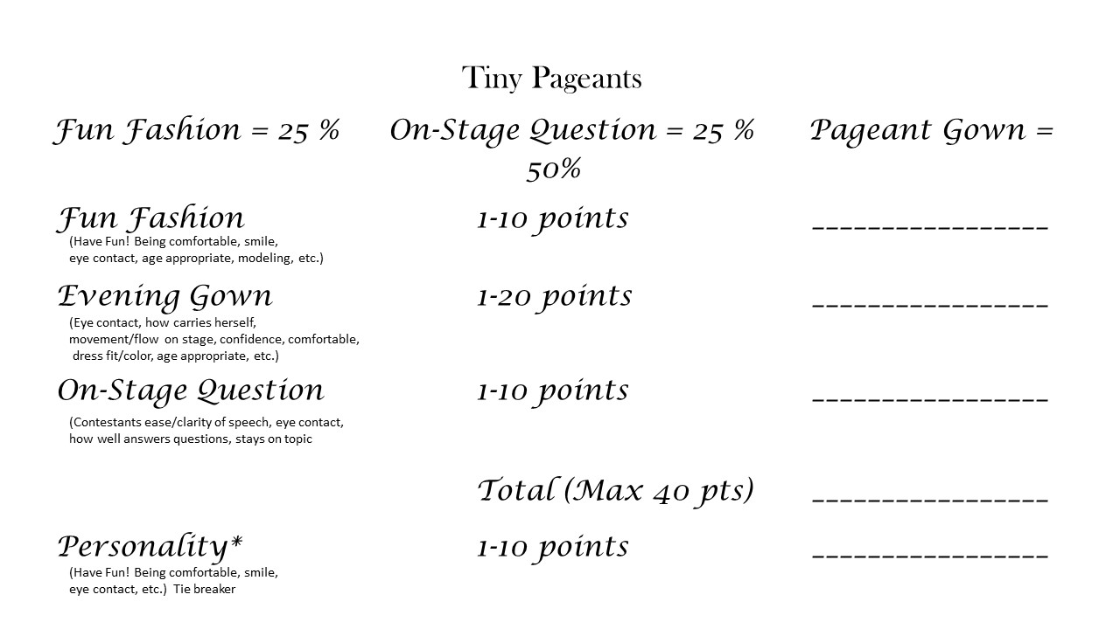
Judging Criteria/ Score Sheets
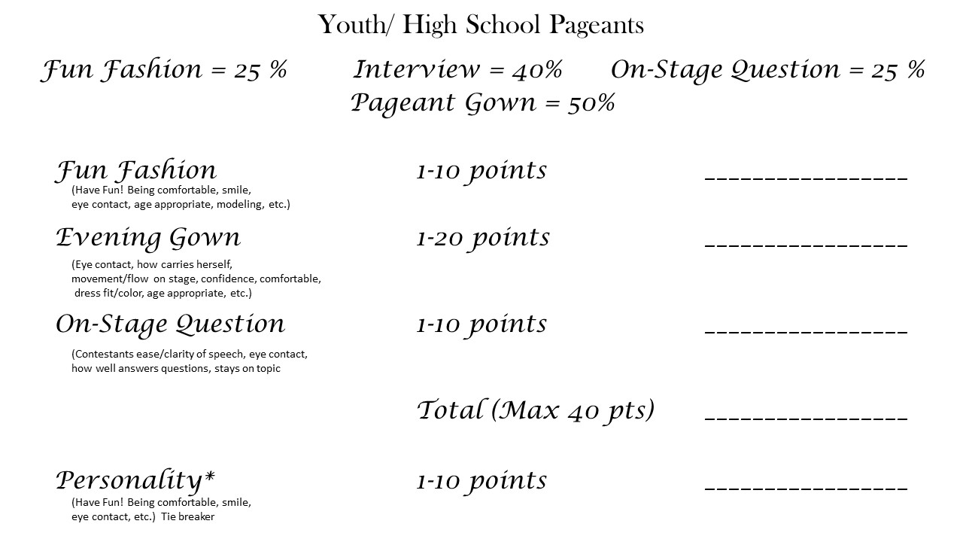

_____________________________________________________________________

Rules & Release - Form A (page 1)
**Note: You will keep this page for your reference and sign & return the next page
In order to insure the integrity of the Miss Discovery Pageants & Program, ALL participants and their parent/guardian must agree to and submit the Rules & Release Form below.
1. Contestants must have been born a female, never been married or had a child. All contestants must meet eligibility requirements and be in good standing with their appropriate school.
2. Judges’ decisions are ﬁnal! Talking with the Judges before, during, or after the pageant is prohibited. If any family, friend, or the contestant herself is caught violating this rule, the contestant will be disqualiﬁed and forfeiture of any and all awards received.
3. Good sportsmanship is required at all times. Failure to show good sportsmanship (including any family or friend of the contestant) will result in disqualiﬁcation of the contestant without refund and forfeiture of any and all awards received. It may also result in contestant not being allowed to compete in the pageant the following year. This rule applies to before, during and after the pageant and includes Twitter, Facebook, Instagram and all other social media sites.
4. Miss Discovery and the PTSA reserve the right to refuse admittance at the pageant to anyone that we feel may be a security risk. This includes rehearsals and volunteer opportunities.
5. Miss Discovery Pageants and the PTSA are not responsible for loss due to injury incurred at, or in travel to and from the pageant. We are not responsible for any thefts that may occur.
6. All registration/entry fees are nonrefundable and nontransferable. Raising ﬁnancial support beyond the registrations fees is strictly optional. At no time will the judges know who raised any funds beyond that until it is announced on stage during the Coronation Ceremony at the end of each pageant.
7. The Photogenic competition is strictly optional. It is not added into the competition scores for the age division’s crowned representative. Also, each contestant is entered into the People’s Choice and the Titan Sweetheart competition.
8. Miss Discovery Pageants and the PTSA require high moral standards and adhere to the Gwinnett County School Board’s “Student Code of Conduct”; therefore any contestant or winner caught engaged in such acts, as drinking alcohol, taking drugs, smoking, foul language, bullying, etc., will be immediately disqualiﬁed at the discretion of the Discovery High School PTSA, Administration and/or Director. This will include posts and pictures from others on your social media pages and/or any pictures and posts from the contestant or winner on her own page or others’ pages. Discovery Queens that are disqualified will forfeit any awards received and the 1st Runner-up will become the new queen.
9. Permission is granted to Miss Discovery Pageants, the Discovery High School PTSA and Discovery High School to use, reproduce, and/or publish photographs and/or video that may pertain to me – including my image, likeness and/or voice without compensation.
10. Permission is granted to Miss Discovery Pageants, the Discovery High School PTSA and Discovery High School to check student’s disciplinary reports. Students may be disqualiﬁed at the discretion of the Discovery High School PTSA, Administration and/or Director.

Rules & Release - Form A (page 2)
Signature Page
As the parents/legal guardian of the participant named below, or as the participant, I do hereby agree to abide by the rules and regulations as set forth by the Miss Discovery Pageants. I agree to hold the Discovery High School, Discovery High School PTSA, Miss Discovery Pageant Committee, and volunteers harmless of any damages or liabilities due to theft, accident, or injury during or resulting from my child’s or my participation in this pageant. I understand and agree that should an act of God (tornado, ﬁre or any other act of nature) cause the cancellation of the pageant, that said pageant will be cancelled without beneﬁt of refund; however, the pageant will be rescheduled at another time and location. I understand that the judges’ decisions are ﬁnal. I understand that good sportsmanship is required at all times. This includes the contestant, parents, and /or guests. I understand that failure to show good sportsmanship will result in disqualiﬁcation of the contestant without refund and forfeiture of any awards received. I agree and understand that all fees are nonrefundable and nontransferable. I agree and give my permission to Discovery High School, Discovery PTSA and the Miss Discovery Pageants to use any and all photographs and or videotapes for publicity purposes on their website, advertisements, or any other materials to promote the Miss Discovery Pageants and Program.

Contestant’s Name (Print):

Contestant’s Signature: |  | Date:

Parent/Guardian’s Name (Print):
Parent/Guardian’s Signature: |  | Date:

Emergency Contact Information - Form B
Complete and Return – Form MUST be typed

Contestant’s Name:
Date of Birth:
Address:
City, State, Zip Code:
Allergies:
Medical Conditions:

In case of emergency, who should be contacted?
Name:
Relationship to Contestant:
Address:
City, State, Zip Code:
Telephone Number:
Other Information:

Parent Volunteer - Form C
We NEED you!!! Please sign up below and volunteer for at least one job in the pageant that your contestant is not competing in. A pageant of this size requires a lot of volunteers. None of the jobs are difficult to perform and we do need you to participate. We can’t do it well without you! Once you commit, you are responsible for the volunteer position. Please list your first, second, and third choice. **Note: Other family members can volunteer as well. Please reach out to your family to see if anyone is interested in assisting us. This is the area of greatest need for the entire pageant production. Please plan to make a day of it so that you can volunteer AND be an audience member to show support for your child’s pageant.

Contestant Name: Age:
Division/Title: Grade:
Mom’s  Name: |  |  |  | Cell Phone:
Volunteer Job |  | # of People Needed Per Pageant | Arrival Time  Amount of Time Prior to Pageant |  | Tiny/Youth School  3:00 pm | High School  7:00 pm
Security (need @ least 1 female per pageant) |  | 3 | 1 Hour
Flower Table |  | 3 | 30 Minutes
Contestant Check-In |  | 2 | 1 Hour
Runner/Assistant |  | 1 | 30 Minutes
Screen Operator |  | 1 | 30 Minutes
Contestant Coordinator |  | 2 | 1 Hour
People’s Choice |  | 2 | 30 Minutes
Ticket Takers |  | 2 | 30 Minutes

Dad’s  Name: |  |  |  | Cell Phone:
Volunteer Job |  | # of People Needed Per Pageant | Arrival Time  Amount of Time Prior to Pageant |  | Tiny/Youth School  11:00 am | High School  6:00 pm
Security (need @ least 1 female per pageant) |  | 3 | 1 Hour
Flower Table |  | 3 | 30 Minutes
Contestant Check-In |  | 2 | 1 Hour
Runner/Assistant |  | 1 | 30 Minutes
Screen Operator |  | 1 | 30 Minutes
Contestant Coordinator |  | 2 | 1 Hour
People’s Choice |  | 2 | 30 Minutes
Ticket Takers |  | 2 | 30 Minutes

Youth/High School (2nd grade – 12th grade only) Contestant Bio - Form D
Please complete 4 copies & turn in 4 copies of this form for Emcee and Interview purposes.
Form MUST be typed.
Pageant Division/Title:

Contestant Name: Age:
School Attending: Grade:
Father’s Name: Mother’s Name:

Person You Would Like To Meet:
Place You Would Like To Visit:
Hobbies & Talents:

Awards & Honors:

Greatest Accomplishment:

Community or Religious Volunteer Service:

Interesting Facts about You Or Your Family:

Future Goals:

Favorites:

Food: TV Show: Song:

Tiny (3 yrs. – 1st grade only) Contestant Bio - Form E
Please complete & turn in 1 copy of this form for Emcee and Interview purposes. Form MUST be typed

Pageant Division/Title:

Contestant Name: Age:
School Attending: Grade:
Father’s Name: Mother’s Name:

Greatest Accomplishment:

Interesting Facts about You Or Your Family:

When She Grows Up, She Would Like To:

Favorites:

Food:

TV Show:

Photogenic Registration - Form F
(This is an optional competition. Complete and turn in ONLY if contestant wishes to compete in Photogenic Competition)
Photogenic is an optional competition: A Photogenic Registration form must accompany each photo submission.
$20.00 Entry (2 photo max)
Deadline:
- January 17, 2020
- Cash/Check/PayPal at www.discoveryhighptsa.weebly.com accepted
Contestant Name: Age:
Division: Grade:

- Photos must have name and division on back in either permanent marker or by label.
- Be sure that ink does not smear.
- Photos should be no smaller than 4 x 6 and no larger than 8 x 10.
- Photos can be in color or black/white.
- Contestants can enter 1 or more photographs.
- A Registration Form should be completed and submitted with each photo along with the proper fees.

*DO NOT mail photographs. Bring photographs in person to DHS. Photos will NOT be accepted after
your contestant’s final rehearsal.

- All photos must be picked up after the pageant. They will be located on a table in the front lobby at the end of your child’s pageant.
- We will not be responsible for any photos left after the pageant.

Date: Received By:

Number of photos: ______________________

Amount of Payment Rec’d: Form of Payment Rec’d:

People’s Choice Award - Form G
(This is an optional competition)

What is the People’s Choice Award?
The People’s Choice Award will become a timeless tradition in the Miss Discovery Pageants for our contestants. Each contestant decorates a shoe box to express who they are and campaign for the audiences vote! Audience members have the opportunity to “vote” for their favorite contestant by putting money in their contestant’s box or bag either before the pageant or during intermission at the People’s Choice Table. You can vote for as many contestants as you would like and as many times as you would like. Vote with cash so the sky’s the limit for your girl!! Acceptable forms of payment are cash and/or check. The contestant with the most “votes” is announced during Coronation Ceremony as our “People’s Choice Winner” for that specific age division and is presented with a rhinestone scepter and flowers!
What do I need to do to participate in the People’s Choice Award?

- You can use a standard size shoe box, photo box, or gift bag, etc.
- Decorate your box or bag to represent you:
- Use photos, small toys, fabric, paint, rhinestones and beads, words, etc. to express who you are!
- Be creative and have FUN!!
- Be sure your name is on the box/bag where people can easily read it.
- If using a box, be sure to have a slot cut on top for your supporters to cast their vote. Also, please leave a way for the Discovery High School PTSA to open the box/bag to count your “votes”!!

Contestants will turn in their People's Choice Box/Bag – March 14, 2020

- Must be delivered on this specific date to Discovery High School on March 14, 2020.
- Please be sure to pick up your box/bag at the end of the pageant.
- We will not be responsible for any boxes or bags left at the school after the pageants.
- Any bags or boxes left will be discarded after the pageant.

Registration - Form H
$10 discount for each additional sibling. Must have proof of residency for all siblings to receive discount.
NO EXTENDED RELATIVES!!
Please select the appropriate division.
 | Current Grade | Division |  | Current Grade | Division
 | 3 - 4 Yrs. | Mini Miss Discovery |  | Home School (9th - 12th Grade) | Miss Greater Discovery Community
 | K – 1st Grade | Tiny Miss Discovery |  | 9th Grade | Miss Freshman Discovery
 | 2nd - 3rd Grade | Petite Miss Discovery |  | 10th Grade | Miss Sophomore Discovery
 | 4th – 5th Grade | Little Miss Discovery |  | 11th Grade | Miss Junior Discovery
 | 6th Grade | Young Miss Discovery |  | 12th Grade | Miss Discovery
 | 7th Grade | Jr Teen Miss Discovery
 | 8th Grade | Teen Miss Discovery

Contestant Name: |  | Age:
Address: |  | City, State,  Zip Code
Home Phone:
School Attending: |  | Current Grade Level:
Contestant’s Cell Phone: |  | Contestant’s Email:
Mother’s Name:
Mother’s Cell Phone: |  | Mother’s Email:
Father’s Name:
Father’s Cell Phone: |  | Father’s Email:

Registration Fees
Full Registration payment due by Jan 17 2020 $ 50.00
Contestant T-shirt Size: 2T 3T 4T 5T
YS YM YL YXL AS AM AL AXL 2XL
*Late registrations, received after Jan 17, may incur additional fees, if application is accepted. Make checks payable to: Discovery High PTSA
Date: _________ Amt Received: __________ Rec’d by: _____
Cash Check Credit Card Official PTSA use only

Age Divisions and Eligibility Requirements

Tiny Pageants: Must attend a school IN/OR reside in Gwinnett County or be related to a Discovery Cluster GCPS employee
- 3 Yrs. – 4 Yrs.: Mini Miss Discovery
- K – 1st Grade: Tiny Miss Discovery
- 2nd - 3rd Grade: Petite Miss Discovery
- 4th – 5th Grade: Little Miss Discovery
Youth Pageants: Must attend a school IN/OR reside in Gwinnett County or be related to a Discovery Cluster GCPS employee
- 6th Grade: Young Miss Discovery
- 7th Grade: Jr Teen Miss Discovery
- 8th Grade: Teen Miss Discovery

High School Pageants: Must attend a school IN/OR reside within the Discovery cluster school zone
- 9th Grade: Miss Freshman Discovery - MUST ATTEND Discovery High School
- 10th Grade: Miss Sophomore Discovery - MUST ATTEND Discovery High School
- 11th Grade: Miss Junior Discovery - MUST ATTEND Discovery High School
- 12th Grade: Miss Discovery - MUST ATTEND Discovery High School
Community Students:
- Miss Greater Discovery Community: Reserved for current 9th-12th Grade Students who live in Gwinnett County but attends a private school, home schooled, or extended campus school.

Wardrobe Checklist
This is a natural pageant, and the contestants overall appearance should reflect such. Tiny contestants will not be allowed to wear make-up. Powder and light lip gloss are acceptable. Youth contestants can wear light make up, but will be judged on the age-appropriateness of their appearance. High school contestants can wear make-up, but will be judged on the appropriateness of their appearance.
Tiny Contestants:
- Pageant/Party dress
- Shoes and accessories
- Opening number outfit: Blue jeans and pageant shirt of your style choosing. Accessories and shoes can be contestant’s choice.
- Fun wear Modeling will be in contestant’s opening number outfit.
Youth Contestants:
- Pageant/Party gown (Floor length)
- Shoes and accessories
- Opening number outfit: Blue jeans and pageant shirt of your style choosing (No bare midriff allowed.) Accessories and shoes can be contestant’s choice.
- Fun wear Modeling will be in contestant’s opening number outfit.
High School Contestants:
- Interview outfit: dress, skirt or pants are acceptable. Choose something that represents you and something you feel comfortable in. You are going for a "job interview."
- Pageant gown (floor length). Slits are allowed in gowns, but cannot be higher than 2" above the knee. Midriff cut-outs are not allowed.
- Shoes and accessories
- Opening number outfit: Blue jeans and pageant shirt of your style choosing (No bare midriff allowed). Accessories and shoes can be contestant’s choice.
- Fun wear outfit of choice with shoes and accessories. You can choose the type of outfit (pants, jeans, skirt, dress, cocktail dress, etc.) with accessories, keeping it age appropriate. We ENCOURAGE you to show personality! Your outfit must adhere to school dress code.
Pre-Sale Flowers
(This is optional)
Miss Discovery Pageants wants to help you show your contestant how much you support them. Give your special contestant roses following her performance!
Roses are available for pre-sale and guaranteed availability. Family & friends can purchase roses online for your stress-free convenience. Your roses’ selection will be beautifully arranged and ready for pick up in the Commons area before your contestant’s pageant. All flower purchases will be submitted via PayPal through our website – www.discoveryhighptsa.weebly.com or cash during a walkup registration event.
Pre-Sale Flowers are available for purchase now through March 1, 2020.
All payments must be received no later than March 1 2020.

Pre-Sale Prices
Red Roses Package Assorted Roses Package (Color May Vary)
A Rose Trio - $7.00 A Rose Trio - $7.00
½ Dozen Roses – $12.00 ½ Dozen Roses – $12.00
Full Dozen Roses - $20.00 Full Dozen Roses - $20.00
Additional roses will be available for sale on a first come, first serve basis on the day of the pageant. Sales will be cash only and colors/quantities cannot be guaranteed
Pageant Day Prices
Red Roses Package Assorted Roses Package (Color May Vary)
A Rose Trio - $10.00 A Rose Trio - $10.00
½ Dozen Roses – $15.00 ½ Dozen Roses – $15.00
Full Dozen Roses - $25.00 Full Dozen Roses - $25.00

Miss Discovery Queen Expectations
Who we are
We represent the Discovery Cluster of Gwinnett County Public Schools. We are in the process of being recognized county-wide and within the Lawrenceville community. Discovery Queens will be the face of this community. What you say and do reflects back on the Discovery Cluster.

Appearance Requirements
The Discovery High PTSA highly recommends that each Discovery Queen and title holder to make a minimum of 2 appearances during your reign. You are welcome to make more appearances throughout the year. This is not mandatory, however, we would like to promote the Discovery Cluster within the Gwinnett County Public School System and raise awareness for our schools within the Lawrenceville community. Your appearances count toward community service and could assist you if you decide to pursue additional pageantry titles.

Community Service
The Discovery High PTSA highly recommends that each HS Discovery Queen and title holder to make a minimum of 20+ hours of community service during your reign. You are welcome to volunteer more throughout the year. The Discovery Queens will be requested to volunteer at a local food pantry, a community event, attend emergency response community activities, and/ or other local community outreach programs. Please use the official community service form provided by your school to receive credit for your hours. These can be obtained in the counselor’s office or with your Parent Instructional Coordinator.
Toastmasters
The Discovery High PTSA highly recommends that each High School Discovery Queen and title holder attend one Toastmasters session each month during your reign. Currently Toastmasters meetings are being held at Discovery HS on Monday evenings from 6:00pm – 8:00pm.

Tips for Successful Appearances:
- Always get your picture taken. Use your camera. Sometimes you may not find the camera person and there is no guarantee that you will see/receive your picture from the event. ALWAYS have someone take a picture with your camera.
- Please only drink out of water bottles. The appearance of other containers doesn’t look professional.
- Please refrain from mood swings and negative attitudes, even when things may go “bad”

